**Advanced Web Tech: Beyond the Basics**

Web development at the advanced level ventures into the realm of performance optimization, scalability, and complex user experiences. Here, front-end frameworks like React and Angular take a backseat to Single-Page Applications (SPAs). SPAs are essentially web applications that load a single HTML page initially and dynamically update content using JavaScript frameworks like Vue.js or Svelte. This approach results in a seamless user experience akin to desktop applications, but requires a deeper understanding of JavaScript concepts like asynchronous programming and virtual DOM manipulation.

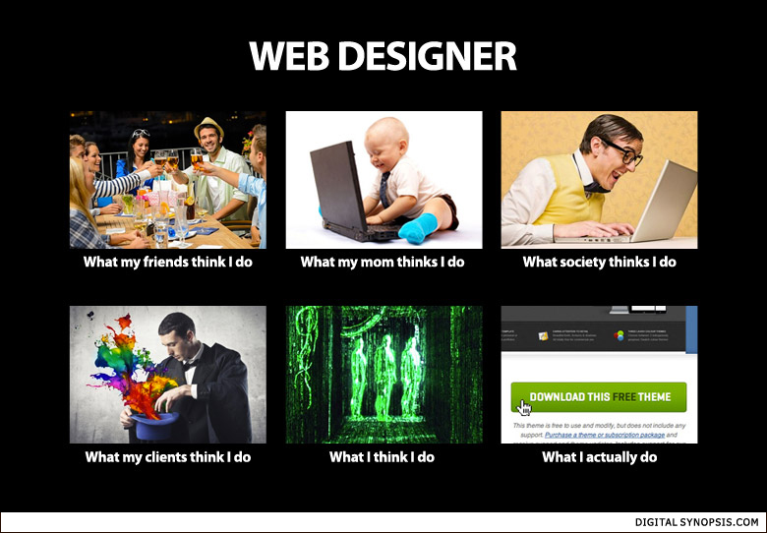

On the back-end, microservices architectures take center stage. These architectures break down large applications into smaller, independent services that communicate via APIs. This allows for faster development cycles, easier deployment, and greater scalability. Technologies like Docker containers and Kubernetes orchestration become essential for managing and deploying these microservices efficiently. Additionally, cloud platforms like AWS, Azure, or GCP offer a vast array of tools and services for building, deploying, and scaling web applications. Understanding these cloud platforms and their functionalities becomes crucial for advanced web development.

Security is also paramount at the advanced level. Techniques like implementing secure coding practices, preventing common web vulnerabilities like SQL injection and Cross-Site Scripting (XSS), and integrating authentication and authorization mechanisms become essential. Advanced developers delve into secure coding practices, threat modeling, and API security to safeguard user data and ensure overall application security.